Preliminary Agency Pet Food Order Form

Please note: We do our best to provide the desired products. If a specific product is not available, a suitable product may be substituted. The OMHS Pet Food Bank is run on a donation basis, therefore we cannot guarantee specific products are always available.
How to determine quantities of food needed:
For easy storage, pet food is delivered in 23”x13”x16” bins, pictured below:
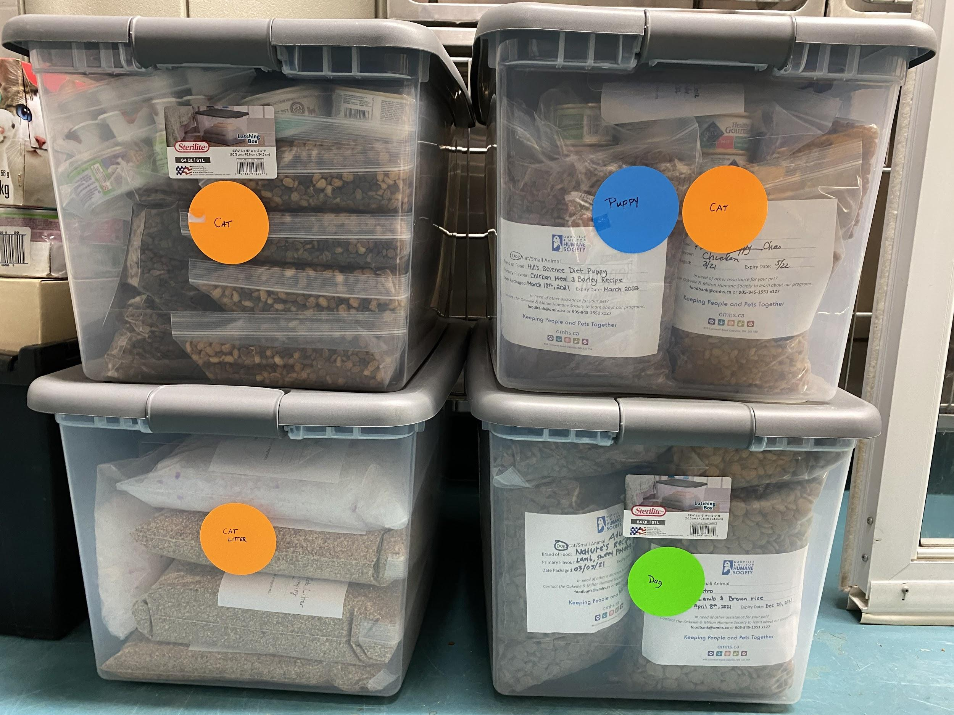
Each bin contains an average of 12 x 1kg bags
On average:
- A medium sized dog (25-45 lbs) will use 1 bag per week.
- An adult cat will use 1 bag every 2 weeks.

Please indicate the estimated number of bins. If you are not aware of the number of clients needing pet food, we recommend starting with 1 bin of adult dog food, 1 bin of adult cat food, and 1 bin of litter.
Food / Supplies Order (select all that apply)
☐ Adult Dog Food: Enter number of Bins
☐ Puppy Food: Enter number of Bins
☐ Senior Dog Food: Enter number of Bins
☐ Wet Dog Food (up to 4 bags added to dry food bin): Enter number of Bins
☐ Adult Cat Food: Enter number of Bins
☐ Wet Cat Food (up to 6 bags added to dry food bin): Enter number of Bins
☐ Kitten Food: Enter number of Bins
☐ Cat Litter (6 bags): Enter number of Bins

Order Frequency (please select one)
☐ Monthly
Is there a specific week or day? (i.e first Monday of every month). If so, please list here: Click or tap here to enter text.
☐ Bi-Weekly
Is there a specific day of the week?
If so, please list here: Click or tap here to enter text.
☐ Weekly
Is there a specific day of the week?
If so, please list here: Click or tap here to enter text.

